THE YOUNGS PIZZA MANAGEMENT SYSTEM (YPMS)

Youngs Pizza is a growing family-owned pizzeria that is doing great, but they are still writing every order down on paper. It is a messy system that is starting to slow them down and cause problems in holding their daily operations back. These include:
- Operational Inefficiency and Errors: Handwritten orders are often very hard to read as they are not clear enough which can lead to wrong, unhappy customers and wasted food.
- No Centralized Data: Customer information, order history and menu details are spread across different slips and notebooks making it hard to quickly access preferences of customers, track and analyze sales trends, or manage inventory properly.
- Poor Order and Delivery Tracking: There's no proper system to track the status of an order from when it was placed down to delivery. This causes delays, miscommunication and makes it hard to hold staff accountable.
- Financial Reporting Challenges: Reconciling daily sales and tracking different payment types is time-consuming and often prone to errors.

The purpose of the Youngs Pizza Management System (YPMS) is to solve these problems by providing a centralized, automated and reliable relational database. This system will serve as the main source of information for all business operations, streamlining workflows, improving customer service and enabling data-driven decision-making.

Technical Requirements
The successful implementation of the YPMS depends on the following technical requirements:
- Relational Database Management System (RDBMS): The system will be built using Oracle Database, developed and maintained using Oracle SQL Developer as the primary interface. This enterprise-grade database platform provides strong data security, reliability and powerful SQL querying capabilities.

- Normalized Database Schema: The database will be designed to at least the Third Normal Form (3NF) to eliminate redundancy and prevent update anomalies. The main entities that will be implemented are:
- Customer
- Employee
- MenuItem
- Order
- OrderItem (Junction Table)
- Payment

- Data Integrity and Constraints: The schema will enforce:
- Primary Keys: Unique identifiers for each record. For example, CustomerID, OrderID.
- Foreign Key Constraints: To make sure related tables are correctly linked. For instance, an Order must have a valid CustomerID.
- Data Type Validation: Using suitable data types such as INT, VARCHAR, DECIMAL, and DATETIME for all attributes.
- Business Rule Constraints: Using CHECK and NOT NULL constraints to ensure valid data. For example, Price must be greater than 0; Order Status can only be specific values or words like 'Pending', 'Completed'.
- Complex Query Support: The database will be designed to efficiently handle a variety of complex business queries including:
- Generating detailed customer order histories.
- Calculating total sales revenue for a specific period.
- Identifying the most popular items on the menu.
Listing all orders handled by a specific employee.

DATABASE DESIGN AND ENTITY RELATIONSHIPS
Entity-Relationship (ER) Modeling: A well-defined ER Diagram was created to visually represent the entities, their attributes and the relationships including cardinality between them before building and implementing the database.

Key Relationships:
Customer to Orders: One customer places many orders. CustomerID is the foreign key in Order
Employee to Orders: One employee handles many orders. EmployeeID is the foreign key in Order.
Orders to OrderItem: One order has many order items. OrderID is the foreign key in OrderItem.
MenuItem to OrderItem: One menu item can appear in many order items. ItemID is the foreign key in OrderItem.
Order to Payment: One order can have many payments. OrderID is the foreign key in Payment
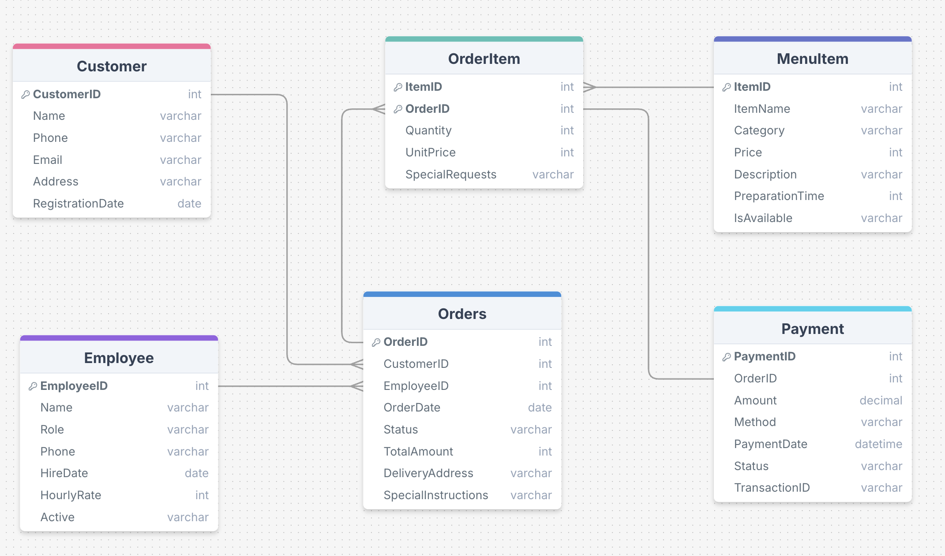

SEQUENCE CREATION FOR PRIMARY KEYS:
For each entity table sequences were set up. The goal is to automate primary key generation.
Each sequence starts at a unique range. This keeps IDs organized by table. Customer IDs start at 1001, employees start at 2001, menu items at 3001, orders at 4001, and payments at 5001.
Using sequences avoids duplicates and removes manual ID entry.

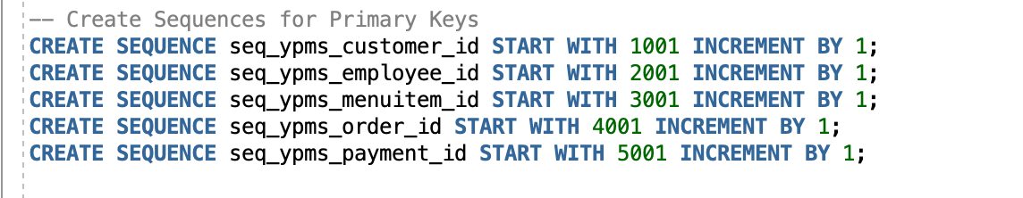

CREATION OF TABLES AND INSERTION OF DATA SAMPLES
Customer Table: We used standard fields such as name, phone, email, and address. RegistrationDate uses SYSDATE so new records get stamped with the current date. For the data sample inserts. Each row uses the customer sequence to create the primary key. These inserts add four sample customers with realistic contact details. The sequence generated customer IDs automatically.
The sample data in the output shows that the table structure works and the inserts run without errors.

Output:
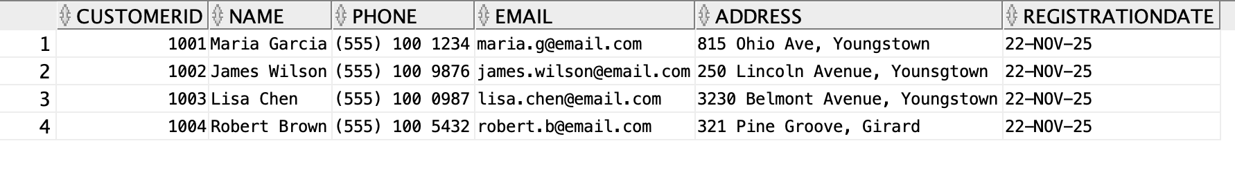

Employee Table: The table stores key information about each worker and the primary key is EmployeeID. Name, role, phone, and hire date help track staff records. HourlyRate stores wage information with a constraint to prevent negative values. Active shows if the employee still works in the business.
For the data sample inserts, the lines add four sample employees to the table. Each worker has a different role which gives us a diverse dataset for testing queries. The hire date uses SYSDATE, so the database sets the date automatically.

Output:
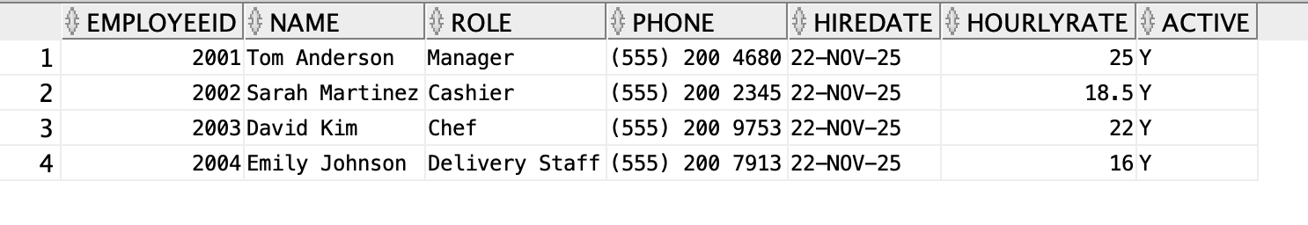

MenuItem Table: This table holds all the items the pizzeria sells. Key attributes are defined like the item name, category, price, a short description, and the preparation time. A check constraint is included to make sure items are assigned only to valid categories like Pizza, Drink, Side, or Dessert. The output contains a few sample menu items and confirms that the table was created successfully and the values were inserted as expected.

Output:
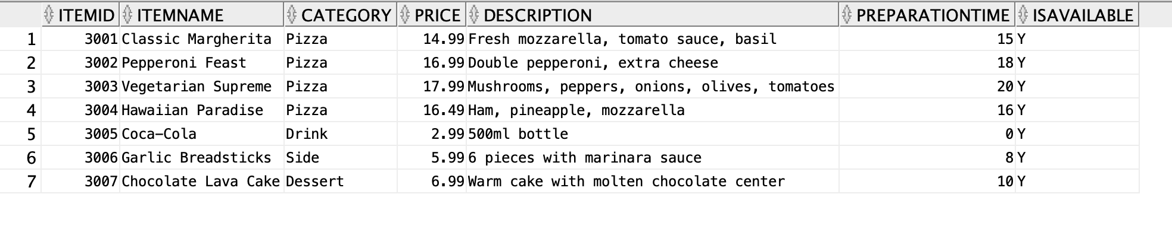

Order Table: Every order placed by a customer is stored here. Foreign keys were added, linking orders to customers and employees. The order status, total amount, delivery address and special instructions were added as well. The output demonstrates different orders in different statuses, verifying the orders were inserted correctly, showing each order with its timestamp and other details.
Output:

OrderItem (Junction Table): This table breaks each order into its individual items So instead of just knowing an order total, we can see exactly which items were purchased, the quantity, the unit price and any special requests. The table includes foreign keys linking each item back to both the order and the menu item. The output shows real-world examples like adding “extra basil” or “no olives” and confirms the line items were inserted successfully.

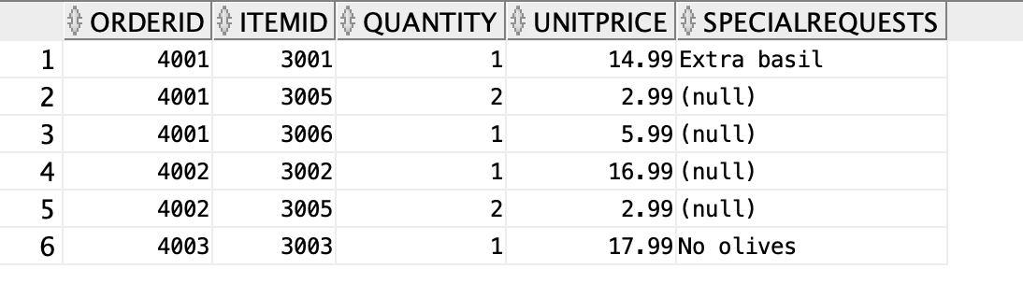

Payment Table: This table handles how orders are paid for, whether by cash, card, debit card or online. Fields for the payment amount, method, status and a transaction ID for tracking were included. The output includes completed payments and one pending payment and shows that the table is working correctly.

Output:
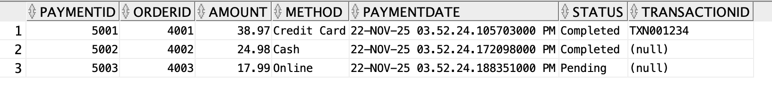

SCENARIO BASED INSIGHTS:
Scenario 1: Finding the top 5 most popular menu items by quantity sold
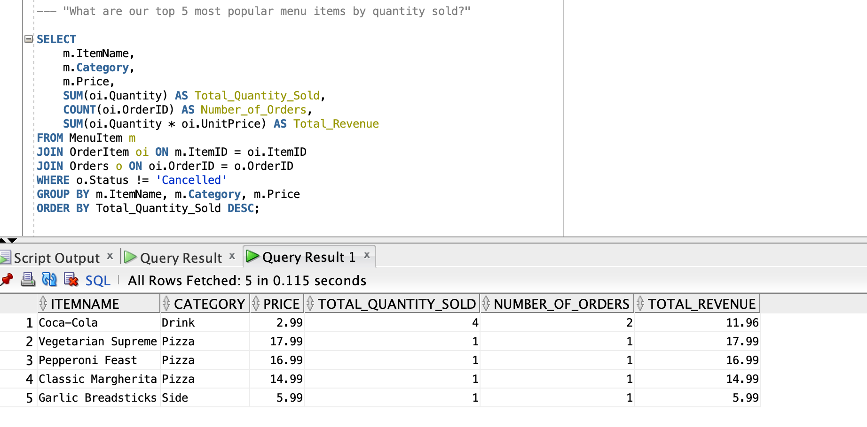

Scenario 2: Finding orders paid in Cash
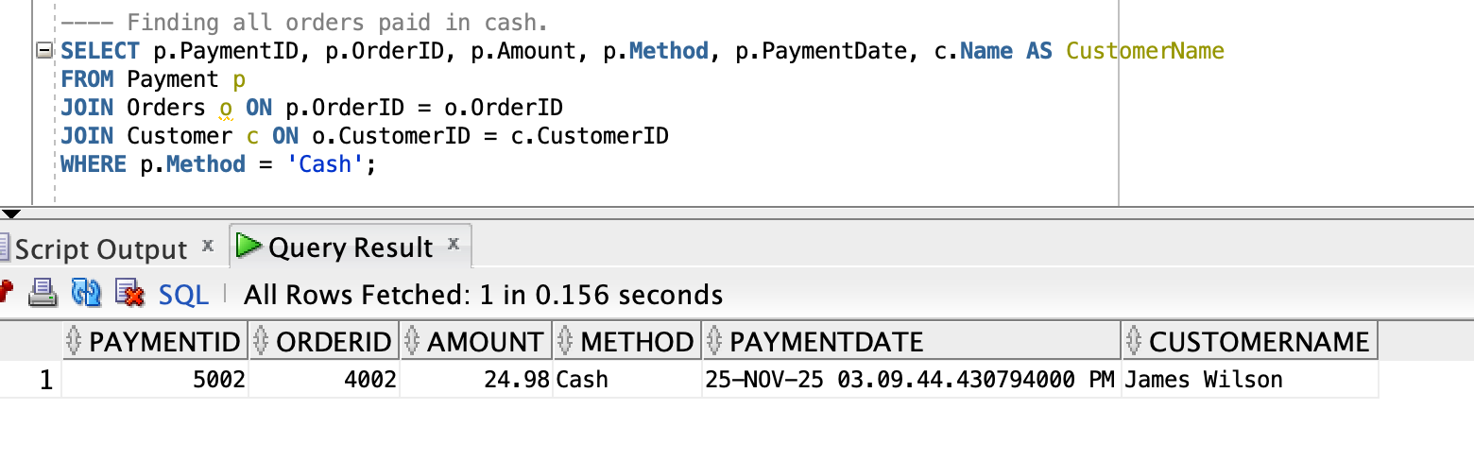

Scenario 3: Finding the average order value
